Task 4

1.TotalRevenue – measure

Kod = TotalRevenue = SUMX('Sales',Sales[OrderQuantity] \* PRODUCT('Product'[ProductPrice]))



2.Average OrderQuantity

Kod = AVGOrder = AVERAGE(Sales[OrderQuantity])

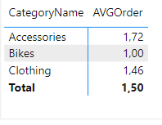

3.ReturnRate

Kod = ReturnRate = DIVIDE(SUM(Returns[ReturnQuantity]), SUM(Sales[OrderQuantity]))

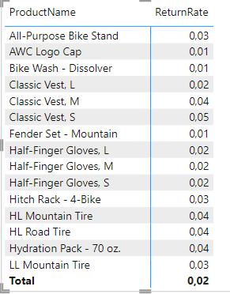

4.DiscountAmount

Kod = DiscountAmount = SUM('Product'[ProductPrice]) - SUM('Product'[DiscountPrice])

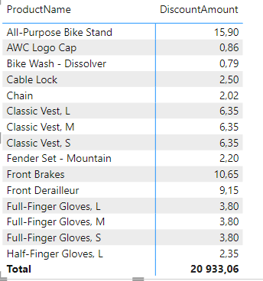

5.GrossProfit

Kod =GrossProfit = SUM('Product'[ProductPrice]) - SUM('Product'[ProductCost])

